
Violence Detection in Surveillance System


1. Project Overview and Team
- Project Title: Violence Detection in Surveillance System
- Institution: Ain Shams University , Faculty of Computer & Information Sciences , Computer Systems Department

- Supervisor: Dr. Karim Omara
- Teaching Assistant: Dr. Omar Khaled

- Team Members: Basma Khaled Mahmoud, Ali Osama Ali Ebrahim, Ahmed Mohamed Mohamed Taha, Shahd Hany Elsayed, Abdelrahman Ahmed Ezzat, and Karim Hossam Elsayed

2. Introduction and Motivation

2.1. Introduction
The Violence Surveillance Detection System is an AI-based solution that utilizes Computer Vision and deep learning to detect violent actions through surveillance cameras in real-time. The system aims to enhance safety by identifying aggressive behavior, weapons, and potential threats.

2.2. Problem Statement
Traditional surveillance systems only record footage without providing real-time alerts, meaning public violence and crimes often go unnoticed until damage has already occurred. This delay prevents quick emergency response and increases risks to civilians, making public safety difficult to maintain without intelligent monitoring.

2.3. Motivation
The motivation for this project is to build a smart surveillance framework using a distributed network of intelligent cameras in districts like Ain Shams. The goal is to enhance public safety, reduce crime, and provide law enforcement with modern tools for effective community protection.

2.4. Objective
The proposed system is an intelligent, automated surveillance network designed to detect violent activities using AI-powered video analysis. Upon detection, alerts are instantly sent to the relevant authorities via a centralized dashboard.

3. System Architecture and Alert Module

3.1. System Architecture
The architecture follows a sequential process:
- CCTV Camera: Captures the initial video stream.
- Pre-processing: The stream undergoes Augmentation, Image Resizing, and Normalization.

- Violence Classifier: Uses models like MobileNet and YOLO to classify the frames.
- Decision Point: Checks if the frame is violence.
  - If Non-violence, the frame is discarded.
  - If Violence, the system proceeds to send the video + location.

- Alert Backend: Receives the violence data.
- Notify Authorities: The final step where authorities are notified.

3.2. Alert Module
The main goals of the alert module are:
- Receive real-time alerts from the AI model upon detection of violence or weapon usage.
- Notify authorized users via the web dashboard.
- Enable operators to review incident details.
The detection system sends JSON data that includes:
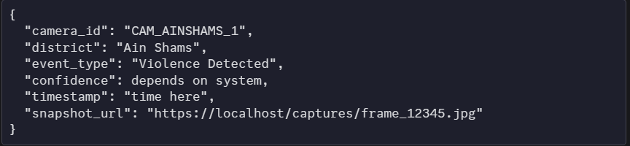

4. Technical Requirements

4.1. Software Requirements
- IDE Tools: Visual Studio Code and Google Colab.
- Programming Languages: Python and PHP.
- Models: MobileNetV2, LSTM, and YOLO for object detection.

4.2. Hardware Requirements
- Primary Components: CCTV cameras and a Local system "Laptop".
- Alternatives Considered: CCTV cameras versus Webcam, and Laptop versus Raspberry Pi.

5. Background Survey and Timeplan

5.1. Literature Survey
The project draws on the following related work:
Title | Authors | Publication Date | Key Method/Model | Accuracy/Notes | Datasets Mentioned
Violence Recognition from Videos using Deep Learning Techniques | Mohamed Mostafa Soliman, Youssef Mohamed Mostafa. | 2019 | End-to-end deep learning model using VGG-16, LSTM, and fully connected layers | Achieves accuracy of 88.2% | RLVS (2000 videos)
Real-Time CCTV Violence Detection Automation System | Atharva Deshmukh, Vaishnavi Dayama. | June 2025 | Real-time CCTV detection using deep learning (CNN and LSTM models) | Used to improve generalization | RLVS, SFD

5.2. Timeplan (Gantt Chart Summary)
The project's timeline spans from August to the following June:

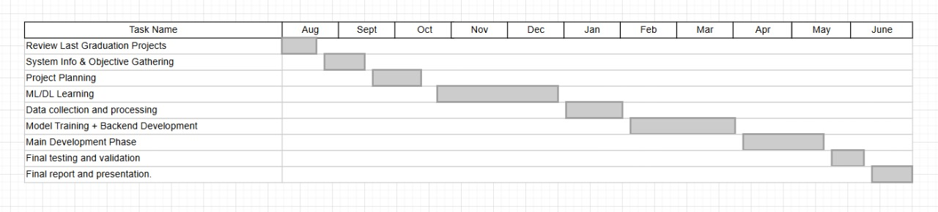

5.3. References (Datasets)
- Smart-City CCTV Violence Detection Dataset (SCVD), published in 2024 by Li Zhiyuan.

- Weapon detection Computer Vision Dataset, published in 2022 by Suhail Hany.

